**SYNOPSIS**

1. **SYNOPSIS**
   1. **TITLE OF THE PROJECT**

Online Crime Management System

* 1. **INTRODUCTION:**

The person who is filing complaint needs to visit the police station personally. When a crime takes place, people dread going to the police station, feeling that filing a complaint can be a tedious task. But, that's not the solution. Now, with the technological invasion into the society a person can file a complaint online for both, cognizable and non-cognizable offences.

“Crime Report Management System” is a website application which reduces the paperwork of the police station. The Objective of Crime Reporting System is to develop a web based program using which people can report crime online. It provides the facility of uploading images or videos of crime scenes to ensure that police may take action immediately. Here we can maintain, add and retrieve all the records like complaint record, criminal record, complaint record, most wanted criminal record, case history, many more in a single database system.

* 1. **PROJECT DESCRIPTION:**

We can say that present platform is manual and does not supply all the information from one place. Presently there is no online web application available to report crime online. In order to report any complains associated with crime, people has to contact closest police station.

“Online Crime Management System” is a web application, handles data of criminals who are under the judicial surveillance or are under trial. This application will be most useful for searching of details of the criminals, FIR details, Prisoners, complaint details, etc.

“Online Crime Management System” covers complete Case Management System and this project will help them to manage all activities of the main police station as well as substation. In this web application we can easily track all the complaint details, criminal details, FIR Details, Charge sheet records, Prisoner records, etc. and it is having some additional features to manage police station records, Online complaint application for police station.

* 1. **PROJECT SCOPE:**
* In ‘Crime Report Management System’ administrator can add cop details, police station details.
* Cops can view complaint details, fir details, case report, charge sheets, crime reports, legal case report, etc.
* Cops can view station wise data and admin can view all data's.
* Cop tasks will be assigned automatically.
* This project helps in keeping all crime details into database. Such that users can easily retrieve and search the details of criminals.
* It helps users to easily register complaints and FIR whenever necessary and can also view their tasks and duties assigned to them by Admin.
* This web application decreases human effort and makes the system less time consuming.
  1. **PRESENT SYSTEM AND PROPOSED SYSTEM:**

**Drawbacks of Existing System:**

• Time consuming.

• More man power.

• Large volume of paper works.

• Needs manual calculation.

**Expected advantages of proposed System:**

• Ensure data accuracy.

• Reduces the damages of the machine.

• Minimizes manual data entry.

• User friendly & interactive.

* 1. **PROJECT CATEGORY:**

Web based application

* 1. **HARDWARE REQUIREMENTS:**
* Processor: Intel dual core or above
* Processor Speed: 1.0GHZ or above
* RAM: 1 GB RAM or above
* Hard Disk: 20 GB hard disk or above
* Operating system: Windows 7 or above
  1. **SOFTWARE REQUIREMENTS:**
* Front End: PHP
* Back End: MySQL
* Programming Server: Apache server
* Database Server: MySQL Server
* Software : XAMPP
* IDE: Notepad++
  1. **MODULE DESCRIPTION:**
     1. **Cop Account Module:**This module allows station admin to add all cop details like name, address, designation, etc into the system. This can also edit or modify.. Admin is the main user of the system. Cops has limited authority. Cops can login to the system by entering User Name and password. Different types of users like Inspector, Sup inspector, Constable, etc can be maintained in the system. Cops can update their profile details and they can change password.
     2. **Location Module:**

This module helps admin to store state, city records. Even admin can add police stationrecords for each station.

* + 1. **Complainer module:**

This module stores complainer profile details. Complainer needs to register to the system. After the login complainer can file or lodge complaint in the complaint section. Complainer can view complaint status, fir status, crime details, charge sheet details, etc.

* + 1. **Complaint Module:**

Any public members can file complaint through online by entering Complaint reason, evidence, complaint details, complaint type, etc. Even police department can file complaint from their account if anyone gives complaint directly by visiting police station. Complaint can be closed anytime if both parties agrees. If the complaint not closed in 2-3 days then the cops has right to add the complaint to FIR.

* + 1. **FIR Module:**

If complaint is cognizable then it goes to FIR. This module enters details of first investigation report(FIR).

* + 1. **Charge sheet Module:**

This module adds charge sheet details based on FIR.

* + 1. **Legal Case Module:**

Once the investigation like FIR, Charge sheet completes, all the details are submitted to the court. So the court hearing details will be added into the system.

* + 1. **Criminal Module:**

Once the court finalize the judgment it will be sent to the criminal Records list.

* + 1. **Criminal Module:**

This module send mail notifications to complaint registrar about complaint registration details, FIR report, Charge sheet report, Legal case report, and criminal report.

* 1. **FUTURE SCOPE OF THE PROJECT:**
* We can integrate this project with Android and iPhone applications.
* We can add face recognition of criminal identification.

**SOFTWARE REQUIREMENT**

**SPECIFICATION**

1. **SOFTWARE REQUIREMENT SPECIFICATION**
   1. **INTRODUCTION OF SRS:**

A **software requirements specification** (SRS) is a description of a [software system](https://en.wikipedia.org/wiki/Software_system) to developed, laying out [functional](https://en.wikipedia.org/wiki/Functional_requirement) and [non-functional requirements](https://en.wikipedia.org/wiki/Non-functional_requirements), and may include a set of cases that describe interactions the users will have with the software.

A basic purpose of the SRS is to bridge this communication gap between client and the developer so they have a shared vision of the software being built. An SRS establishes the basis for agreement between the client and the supplier on what the software product will do. SRS provides a reference for validation of the final product. A high-quality SRS is a prerequisite to high-quality software and also reduces the development cost.

The person who is filing complaint needs to visit the police station personally. Mostly, when a crime takes place, people dread going to the police station, feeling that filing a complaint can be a tedious task. But, that's not the solution. Now, with the technological invasion into the society a person can file a complaint online for both, cognizable non-cognizable offences. This Web application is for police station which provides facility for reporting crimes, complaints, FIR, charge sheet, prisoner records, show most wanted criminals details, law and order details as well as court details. It also track police station constable details, police information, attendance details, salary report, over time, etc.

* 1. **PURPOSE OF SRS:**

This Document includes software requirements for the “Crime Report Management System” Project. The purpose of this document is to detail the user requirements for all the functionality in “Crime Report Management System”. This document is meant to serve as a guide to the developers and users. The purpose of the requirement document is to specify and provide all the information required to design, develop and test the system. This document ensures that the person reading the document understands what she/he is looking for.

We can say that present platform is manual and does not supply all the information from one place. Presently there is no online web application available to report crime online. In order to report any complains associated with crime, people has to contact closest police station.

The person who is filing complaint needs to visit the police station personally. Mostly, when a crime takes place, people dread going to the police station, feeling that filing a complaint can be a tedious task. But, that's not the solution. Now, with the technological invasion into the society a person can file a complaint online for both, cognizable non-cognizable offences.

“Crime Report Management System” is a website in which will reduce the paperwork of the police station. This project is maintained in a single server and it makes handling of records easier. Here we can maintain, add and retrieve all the records like criminal record, complaint record, most wanted criminal record, case history, many more in a single database system.

* 1. **SCOPE OF SRS:**

This project has following features and scopes:

* We make a system with at most comfort and the highest standard of feminine care.
* In ‘Crime Report Management System’ Admin register’s users details ie. Employees of police station and so that Admin & Users can retrieve and add information on to it.
* It is beneficiary for Admin to assign tasks and duties to the employees instead of doing in paper works and it will also helps in keeping all crime details into database. Such that users can easily retrieve and search the details of criminals.
* It helps users to easily register complaints and FIR whenever necessary and can also view their tasks and duties assigned to them by Admin.
* Thus it decreases human effort and makes the system less time consuming.
* Administrator has full authority of the website.
* This application basically uses database to store the information.
  1. **DEFINITIONS, ACRONYMS AND ABBREVIATIONS:**
* **SRS:** Software Requirements System
* **OS:** Operating System
* **PHP:** PHP: Hypertext Pre-processor
* **PC:** Personal Computer
* **MB:** Mega Bytes
* **RAM:** Random Access Memory
* **MySQL:** MySQL database Server
  1. **REFERENCES:**
* www.w3schools.com
* www.tutorialspoint.com
* www.stackoverflow.com
* Web Database Applications with PHP and MySQL By Hugh E. Williams, ‎David Lane
* An integrated approach to Software Engineering By Pankaj Jalote
  1. **OVERVIEW:**

This SRS will allow for a complete understanding of what is to be expected of the “Crime Report Management System” web application to be constructed. The clear understanding of the “Crime Report Management System” System and its functionality will allow for end users and will be used for the development of the future stages of the project.

* + 1. **OVERALL DESCRIPTION:**

This section of the SRS describes all general factors of the product and its requirements. This SRS explains detailed requirements of Crime Report Management System. “Crime Report Management System” is a web application, handles data of criminals who are under the judicial surveillance or are under trial. This application will be most useful for searching of details of the criminals, FIR details, Prisoners, complaint details, etc.

* + 1. **PRODUCT PERSPECTIVE:**

Current developing project is the web application project developing using PHP. This system is developed using PHP and all the record stores in the MySQL database.

* + 1. **PRODUCT FEATURES:**

This product has following features:

* Only authenticated users can access this website
* This system is developed to facilitate to provide efficient, inexpensive, well grounded, well planned and comfortable usage.
* Administrator can view all features of the website.
  + 1. **USER CLASSES AND CHARACTERISTICS:**

There are 3 types of users using for this system.

The system provides access to Visitors, Customers and Administrators.

* **Administrator**: Administrator is the super user of the website. He has the website authority to control. Administrator has the right to add, edit, delete Cop, station details, location details, etc.
* **Cop**: Cops are the inspectors who work for Police station. Cops can view complaint record, they can file FIR, etc. Cops can manage complete police station activities.
* **Complainer:** Complainers can file complaint to the police station by entering their profile details. Complainers need to fill Online complain form with complaint details, evidence details, accuser details, etc.
  + 1. **DESIGN AND IMPLEMENTATION CONSTRAINTS:**
* The developed system should run under any platform (Unix, Linux, Mac, Windows etc.) that contains a web browser which supports PHP, JavaScript and AJAX.
* Internet connectivity is required to send mails.
* The user who is accessing the system should be authorized.
* MySQL database is the backend of the system.
* Complainer cannot view police station activities or admin activities.
* This system is not support distributed database Facility.
* System is limited to HTTP/HTTPS Protocols.
* The system needs following tables undercrime_report database.
  + chargesheet
  + city
  + complainer
  + complaint
  + cop
  + crime_report
  + designation
  + fir
  + legalcase
  + prisoner
  + state
  + station
    1. **ASSUMPTIONS AND DEPENDENCIES:**
* The users should have basic knowledge of the computers. They must be trained well to handle the features provided by this system.
* Some of the details are required to be entered by the user and may not be generated automatically.
* Administrator is created in the system already.
* Roles and tasks are predefined.
* The user should operate in computer or mobile phone with internet facility.
  1. **SPECIFIC REQUIREMENTS:**
     1. **EXTERNAL INTERFACE REQUIREMENTS:**

This chapter is an outline of the inputs and outputs of the project. The following sections will introduce the numerous requirements of the system from the point of view of different users and will introduce a number of decisions that have been made regarding implementation. These sections also attempt to somewhat describe the role of each user group in the system, discussing their individual roles through the functions they can perform.

* + 1. **USER INTERFACES:**

Each part of the user interface intends to be as user friendly as possible. The fonts and buttons used will be intended to be very fast and easy to load on web pages. The pages will be kept light in space so that it won’t take a long time for the page to load.

* + 1. **HARDWARE INTERFACES:**
* **Operating System:** Unix, Linux, Mac, Windows etc.
* **Processor:** Pentium or Higher.
* **RAM:** 312MB or Higher.
* **Input Devices:** Keyboard and mouse
* **Output Devices:** Monitor, Printer
  + 1. **SOFTWARE INTERFACES:**
* **Development tool:** PHP : Hypertext Preprocessor, JavaScript, Ajax
* **Scripting server:** Apache server
* **Data Base server:** MySQL
* **IDE:** Notepad++
  + 1. **COMMUNICATION INTERFACES:**

This is a web based system and communication is done through internet and internet protocol

* 1. **FUNCTIONAL REQUIREMENTS:**
     1. **Complainer module:**

This module stores complainer profile details. Complainer needs to register to the system. After the login complainer can file or lodge complaint in the complaint section. Complainer can view complaint status, fir status, crime details, charge sheet details, etc.

The sub modules are:

* + Complainer Registration
  + Complainer Login
  + Change Password
  + Complainer Profile
    1. **Complaint Module:**

Any public users can file complaint through online by entering Complaint reason, evidence, complaint details, complaint type, etc. Even police department can file complaint from their account if anyone gives complaint directly by visiting police station. Complaint can be closed anytime if both parties agrees for close.

The sub modules are:

* + Complaint reason
  + Complaint details,
  + Complaint type
  + Evidence
    1. **Cop Account Module:**

This module allows station admin to add all cop details like name, address, designation, etc into the system. This can also edit or modify. Admin is the main user of the system. Cops has limited authority. Cops can login to the system by entering User Name and password. Different types of users like Inspector, Sup inspector, Constable, etc can be maintained in the system. Cops can update their profile details and they can change password.

The sub modules are:

* + Cop Login
  + Cop Profile
  + Cop change password
    1. **Location Module:**

This module helps admin to store state, city records. Even admin can add police station records for each station.

The sub modules are:

* + Add state
  + View state
  + Add city
  + View city
    1. **FIR Module:**

If complaint is cognizable then goes to FIR. So in this module further investigation report is added into the system for cognizable complaints.

The sub modules are:

* + File FIR
  + View FIR
    1. **Charge sheet Module:**

In this module station user adds Charge sheet details will be added based on complaint.

The sub modules are:

* + Add charge sheet report
  + View charge sheet report
    1. **Legal Case Module:**

Once the investigation like FIR, Charge sheet completes, all the details are submitted in to court. So the court hearing details will be added into the system.

The sub modules are:

* + Add Legal case
  + View legal case
    1. **Criminal Module:**

Once the court finalize the judgment it will be sent to the criminal Records list.

The sub modules are:

* + Add criminal list
  + View criminal list
    1. **Mail settings module:**

This module send mail notifications to complaint registrar about complaint registration details, FIR report, Charge sheet report, Legal case report, and criminal report.

The sub modules are:

* + Mail settings
  1. **DOCUMENT CONVENTIONS:**

The format of this SRS is simple. Bold face and indentation is used on general topics and or specific points of interest. The remainder of the document will be written using the standard font New Times Roman.

* 1. **INTENDED USERS AND READING SUGGESTIONS:**

This document is intended for software developers, document writers and for general discussions on the implementation decisions regarding the software.

* 1. **SYSTEM FEATURES:**

The coding is done with following characteristics in mind:

* Ease of design to code translation
* Code efficiency
* Memory efficiency
* Response time
* Maintainability
* Security
* Simple ease to understand code
* Efficient and consistent logic
  1. **OTHER NON-FUNCTIONAL REQUIREMENTS:**
     1. **PERFORMANCE REQUIREMENTS:**

Performance requirements define acceptable response times for system functionality.

* The system is supposed to be having good memory space and RAM should be Above 256 MB preferably.
* The sound card and graphics card will have to be of good quality and capacity.
* The load time for user interface screens shall take no longer than three seconds.
* The log in information shall be verified within three seconds.
* Queries shall return results within three seconds.
  + 1. **SAFETY REQUIREMENTS:**
* In case if the student forgets their password, they can recover the password in the Forgot Password panel.
* The password stores in the database in the format of encrypted password.
  + 1. **SECURITY REQUIREMENTS:**
* Only authenticated users can access this system.
* Employee and Admin has different interface to increase the security.
  1. **SOFTWARE QUALITY ATTRIBUTES:**
     1. **Reliability:**

This system is designed to have very simple database just to cater the exact need of “Crime Report Management System” project. It is tested for all the constraints at development stage.

* + 1. **Availability:**
  + This system will only available till the system on which it is installed is running.
    1. **Security:**
  + This system is provided with authentication without which no user can pass. So only the legitimate users are allowed to use the application. If the legitimate users share the authentication information then the system is open to outsiders.
    1. **Maintainability:**
  + There is maintenance required for the website. The database is provided by the Administrator as well as the end-use.
    1. **Portability:**
  + The system works anywhere with the internet connection.
  1. **OTHER REQUIREMENTS:**

None

**SYSTEM DESIGN**

1. **System Design**
   1. **INTRODUCTION :**

Design is a process through which requirements are translated into a representation of the software. The purpose of the designing phase is to plan a solution for the problem specified by the requirement document. This phase moves from the problem domain to the solution domain i.e. the requirements are translated into software.

The design activity often results in three separate outputs:

1. Architecture design
2. High level design
3. Detailed design

In architecture design the focus is on identifying components or subsystems and how they interact to each other. The high level design identifies the modules that should build for developing the system. In case of detailed design the focus is on how the modules are implemented in software.

System design is a solution, a “How to” approach to the creation of a new system. The important phase is composed of several steps. It provides the understanding of procedural details necessary for implementing the system recommended in the feasibility study. Emphasis is on translating the performance requirements into design specifications.

* 1. **APPLICABLE DOCUMENTS:**

The document used in system design is Software Requirement Specification Document.

* 1. **FUNCTIONAL DECOMPOSITION :**

The system can be decomposed into functional components as follows.

* The aim of Online Crime Reporting System will be to create a web based program using which people are able to report crime online.
* It gives the facility of uploading videos or images of crime scenes to ensure that authorities can take action immediately.
* This project can help in storing the records related to the criminals, cases, complaint record, case history and so on.
* It can also help in minimizing most of the work of the police.
* This web application can contain the details related to the criminals in the particular case.
* The details of the prisoner and his case related details can be stored in the database.
* The details of the complaints that are registered can also be stored through this application.
* The details of the police in the particular police station can be maintained through this application.
  1. **CONTEXT FLOW DIAGRAM** :
     1. **CONTEXT FLOW DIAGRAM (LEVEL 0):**

Context flow diagram is a top level data flow diagram. It only contains one process note that generalises the function of the entire system in relationship to external entities. In context diagram the entire system is treated as a single process and all its inputs, outputs, sinks and sources are identified and shown.

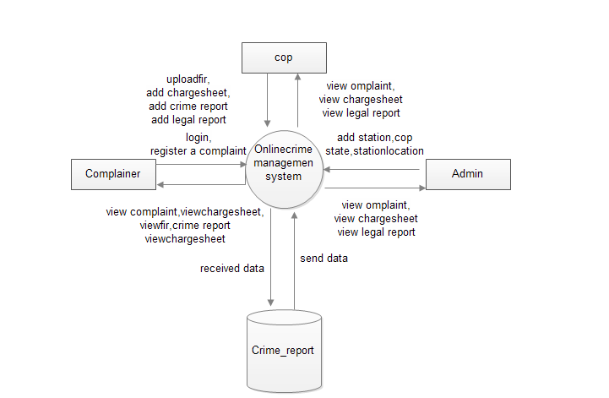

* + 1. **DATA FLOW DIAGRAM**:

A data flow diagram is a graphical representation of the flow of data through an information system. A data flow diagram can also be used for the visualization of the data processing. It is common practice for a designer to draw a context level DFD. It shows the interaction between the system and the outside entities. This context level DFD, is then exploded to show more detail of the system being modeled.

A DFD represents flow of data through a system. Data flow diagrams are commonly used during problem analysis. It views a system as a function that performs the input into the desired output. A DFD shows movement of data through the different transformations or processes in the system.

Data Flow diagrams can be used to provide the end users with the physical idea of where the data they input ultimately has an effect upon the structure of whole system from order to dispatch to restock how any system is developed can be determined through data flow diagram. The appropriate register saved in database and maintained by appropriate authorities.

* + 1. **NOTATIONS USED IN THE DFD :**

|  |  |
| --- | --- |
| **Symbol** | **Description** |
|  | The circle or bubble represents a process. A process is named and each process is represented by a named circle. |
|  | The source or sink is represented as a rectangular box. The source or sink is the net originator or the consumer of the data that flows in the system. |
|  | The arrow represents the flow of data through the system. The labeled arrows enter or leave the bubbles. |
|  | The database is represented with the open box symbol. |

* + 1. **Top Level DFD Level 2.0:**

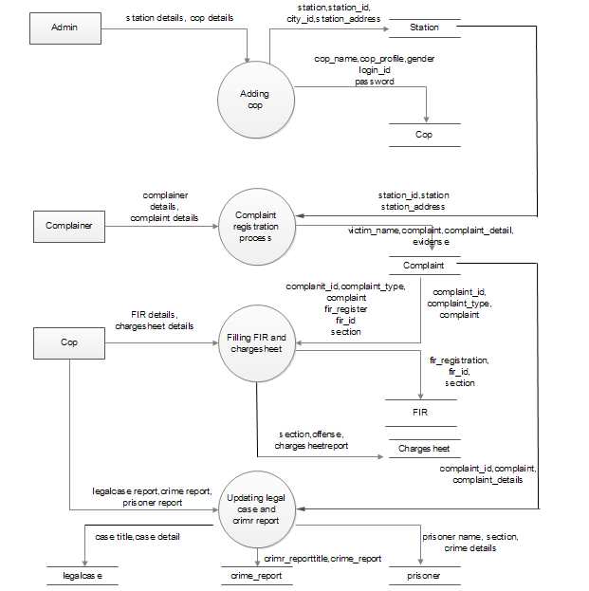

* + 1. **DFD Level 2.1:**

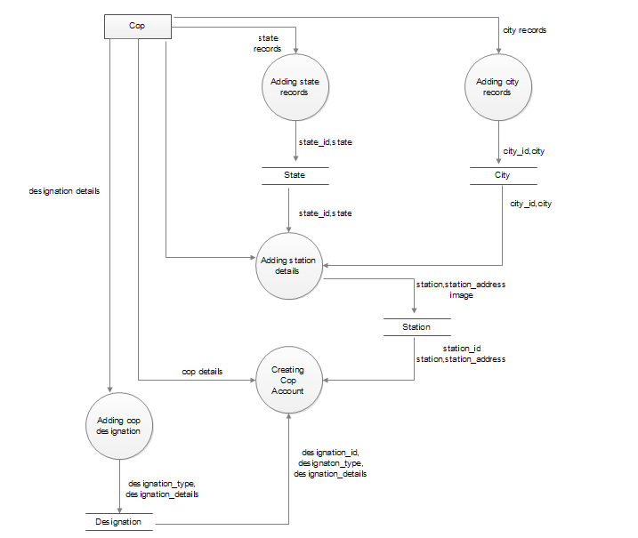

**DESCRIPTION OF COMPONENT:**

* **Input** :
* City records
* State records
* Designation details
* Cop details
* Cop designation details
* **Process Definition:**
* Adding City records
* Adding state records
* Adding Designation details
* Adding Cop details
* Adding Cop designation details
* **Output definition:**
* City record stores in city table
* State record stores in state table
* Cop designation master detail stores in designation table
* Cop account detail stores in cop table.
  + 1. **DFD LEVEL 2.2:**

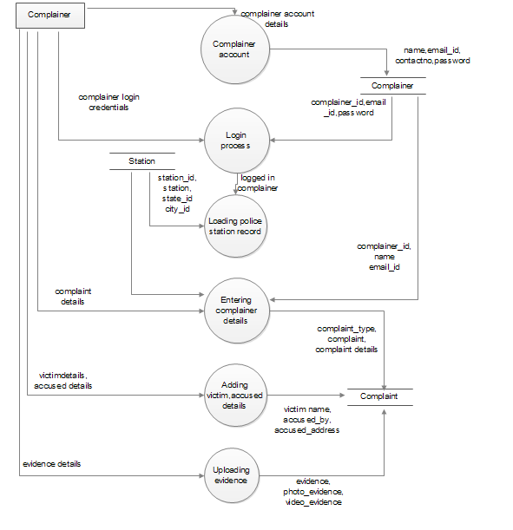

**DESCRIPTION OF COMPONENT:**

* **Input** :
* Complainer registration detail
* Complainer Login detail
* Complaint detail
* Victim detail, Accused detail
* Evidence detail
* **Process Definition:**
  + Complainer Account
  + Login process
  + Loading police station record
  + Entering complainer detail
  + Adding victim and accused detail
  + Uploading evidence

* **Output definition:**
* Complainer detail stores in complainer table
* Complainer can login to the website. Complainer login credentials verified from complainer table.
* Station record received from station table
* Complaint detail, Victim detail, Accused detail, Evidence detail stores in complaint table.
  + 1. **DFD LEVEL 2.3:**

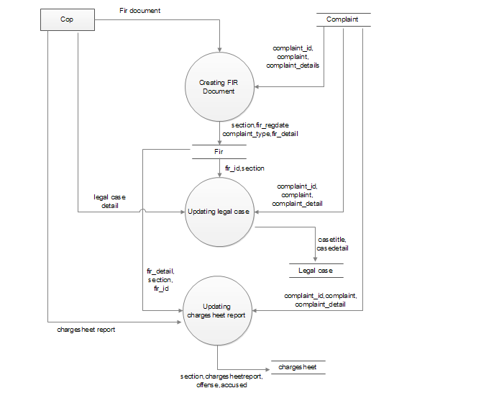

**DESCRIPTION OF COMPONENT:**

* **Input** :
* FIR Document
* Legal case detail
* Updating Charge sheet report
* **Process Definition:**
* Creating FIR on complaint
* Updating legal case detail
* Updating charge sheet report
* **Output definition:**
* Complaint detail received from complaint table
* Legal case updation stores in legalcase table
* Charge sheet report stores in chargesheet table
  + 1. **DFD LEVEL 2.4:**

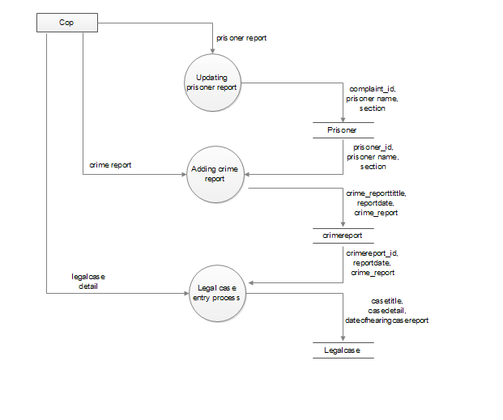

**DESCRIPTION OF COMPONENT:**

* **Input** :
* Prisoner Report
* Crime Report
* Legal case report
* **Process Definition:**
  + - * Updating prisoner list
      * Adding crime report
      * Legal case entry process
* **Output definition:**
  + - * Prisoner report stores in prisoner table
      * Crime report stores in crimereport table
      * Legal case detail stores in legal case table.

**DATABASE DESIGN**

1. **Data Base Design**
   1. I**NTRODUCTION :**
      1. **Database :** A Database is collection of related data, which can be of any size and complexity. By using the concept of Database, we can easily store and retrieve the data. The major purpose of a database is to provide the information, which utilizes it with the information’s that the system needs according to its own requirements.
      2. **Database Design :**Database design is done before building it to meet needs of end-users within a given information-system that the database is intended to support. The database design defines the needed data and data structures that such a database comprises The database is physically implemented using MySQL.
      3. The database crime_report is organized into12 tables:

* chargesheet
* city
* complainer
* complaint
* cop
* crime_report
* designation
* fir
* legalcase
* prisoner
* state
* station
  1. **TABLE DESIGN :**

Each entity can be described as follows along with its attributes:

## Table Name: station

|  |  |  |  |
| --- | --- | --- | --- |
|  | **Type** | **Index** | **Description** |
| ***station_id*** | int(10) | Primary Key | Station ID |
| Station | varchar(100) | No | Station Name |
| state_id | int(10) | Foreign Key | State ID |
| city_id | int(10) | Foreign Key | City ID |
| station_addresss | text | No | Station Address |
| contact_no | varchar(15) | No | Contact Number |
| Img | varchar(100) | No | Station image |
| description | text | No | Station Description |
| status | varchar(10) | No | Station status |

## Table Name: cop

|  |  |  |  |
| --- | --- | --- | --- |
| **Column** | **Type** | **Index** | **Description** |
| ***cop_id*** | int(10) | Primary Key | Cop ID |
| cop_name | varchar(50) | No | Cop Name |
| station_id | int(10) | Foreign Key | Station ID |
| designation_id | int(10) | Foreign Key | Designation ID |
| img | varchar(100) | No | Cop Image |
| cop_pofile | text | No | Cop Profile |
| gender | varchar(10) | No | Gender |
| contact_no | varchar(10) | No | Contact Number |
| email_id | varchar(100) | No | Email ID |
| login_id | varchar(25) | Unique | Login ID |
| password | varchar(12) | No | Password |
| description | text | No | Cop Description |
| status | varchar(10) | No | Cop Status |

## Table Name: complainer

|  |  |  |  |
| --- | --- | --- | --- |
| **Column** | **Type** | **Index** | **Description** |
| ***complainer_id*** | int(10) | Primary Key | Complainer ID |
| name | varchar(50) | No | Complainer Name |
| email_id | varchar(50) | Unique | Complainer Email ID |
| phoneno | varchar(14) | Unique | Complainer PhoneNumber |
| password | varchar(100) | No | Password |
| status | varchar(10) | No | Complainer Status |

## Table Name: complaint

|  |  |  |  |
| --- | --- | --- | --- |
| **Column** | **Type** | **Index** | **Description** |
| ***complaint_id*** | int(10) | Primary Key | Complaint ID |
| station_id | int(10) | Foreign Key | Station ID |
| state_id | int(10) | Foreign Key | State ID |
| city_id | int(10) | Foreign Key | City ID |
| complainer_id | int(10) | Foreign Key | Complainer ID |
| complaint_type | varchar(25) | No | Complaint Type |
| complaint | varchar(500) | No | Complaint |
| accusedby | varchar(50) | No | Accused By |
| complaint_detail | text | No | Complaint Details |
| complaint_date | datetime | No | Complaint Dta |
| victim_address | text | No | Victim Address |
| accused_address | text | No | Accused Address |
| victims_name | varchar(50) | No | Victim Name |
| victim_phoneno | varchar(10) | No | Victim PhoneNumber |
| accused_phoneno | varchar(10) | No | Accused PhoneNumber |
| evidence | text | No | Evidence |
| photo_evidence | varchar(100) | No | Photo Evidence |
| video_evidence | varchar(100) | No | Video Evidence |
| anynote | text | No | Anynote |
| complaint_status | text | No | Complaint status |
| status | varchar(10) | No | Status |

## Table Name: chargesheet

|  |  |  |  |
| --- | --- | --- | --- |
| **Column** | **Type** | **Index** | **Description** |
| ***chargesheet_id*** | int(10) | Primary Key | Chargesheet ID |
| complaint_id | int(10) | Foreign Key | Complaint ID |
| fir_id | int(10) | Foreign Key | Fir ID |
| section | varchar(100) | No | Section |
| chargesheetreport | text | No | ChargesheetReport |
| offense | text | No | Offence |
| accused | text | No | Accused |
| description | text | No | Description |
| chargesheetdocs | varchar(100) | No | Chargesheetdocuments |
| status | varchar(100) | No | Status |

## Table Name: city

|  |  |  |  |
| --- | --- | --- | --- |
| **Column** | **Type** | **Index** | **Description** |
| ***city_id*** | int(10) | Primary Key | City ID |
| city | varchar(50) | No | City |
| state_id | int(10) | Foreign Key | State ID |
| description | text | No | Description |
| status | varchar(10) | No | Status |

## Table Name: crime_report

|  |  |  |  |
| --- | --- | --- | --- |
| **Column** | **Type** | **Index** | **Description** |
| ***crimereport_id*** | int(10) | Primary Key | Crimereport ID |
| complaint_id | int(10) | Foreign Key | Complaint ID |
| reportdate | date | No | Complaint report date |
| crime_reporttitle | varchar(100) | No | Crimereport tittle |
| crime_report | text | No | Crime report |
| status | varchar(100) | No | Status |

## Table Name: designation

|  |  |  |  |
| --- | --- | --- | --- |
| **Column** | **Type** | **Index** | **Description** |
| ***designation_id*** | int(10) | Primary Key | Designation ID |
| designation_type | varchar(50) | No | Designation Type |
| designation_details | text | No | Designation details |
| status | varchar(10) | No | Status |

## Table Name: fir

|  |  |  |  |
| --- | --- | --- | --- |
| **Column** | **Type** | **Index** | **Description** |
| ***fir_id*** | int(10) | Primary Key | Fir ID |
| complaint_id | int(10) | Foreign Key | Complaint ID |
| section | varchar(100) | No | Section |
| complaint_type | varchar(50) | No | Complaint Type |
| fir_regdate | date | No | Fir registration date |
| fir_detail | text | No | Fir details |
| fir_start_date | date | No | Fir start date |
| fir_end_date | date | No | Fir end date |
| status | varchar(10) | No | Status |

## Table Name: legalcase

|  |  |  |  |
| --- | --- | --- | --- |
| **Column** | **Type** | **Index** | **Description** |
| ***legalcase_id*** | int(10) | Primary Key | Legalcase ID |
| complaint_id | int(10) | Foreign Key | Complaint ID |
| fir_id | int(10) | Foreign Key | Fir ID |
| chargesheet_id | int(10) | Foreign Key | Chargesheet ID |
| casetitle | varchar(100) | No | Casetitle |
| casedetails | text | No | Casedetails |
| dateofhearing | datetime | No | Date of case hearing |
| casereport | text | No | Casereport |
| casedocument | varchar(100) | No | Casedocuments |
| casestatus | varchar(20) | No | Casestatus |

## Table Name: prisoner

|  |  |  |  |
| --- | --- | --- | --- |
| **Column** | **Type** | **Index** | **Description** |
| ***prisoner_id*** | int(10) | Primary Key | Prisoner ID |
| complaint_id | int(10) | Foreign Key | Complaint ID |
| fir_id | int(10) | Foreign Key | Fir ID |
| chargesheet_id | int(10) | Foreign Key | Chargesheet ID |
| crimereport_id | int(10) | Foreign Key | Crimereport ID |
| prisonername | varchar(50) | No | Prisoner Name |
| section | varchar(100) | No | Section |
| crimedetails | text | No | Crime details |
| prisoneraddress | text | No | Prisoner address |
| prisonerimg | varchar(100) | No | Prisoner Image |
| prisinerdocument | varchar(100) | No | Prisoner Documents |
| anynote | text | No | Anynote |
| status | varchar(10) | No | Status |

## Table Name: state

|  |  |  |  |
| --- | --- | --- | --- |
| **Column** | **Type** | **Index** | **Description** |
| ***state_id*** | int(10) | Primary Key | State ID |
| state | varchar(50) | No | State |
| description | text | No | State description |
| status | varchar(10) | No | Status |

* 1. **ENTITY-RELATIONSHIP DIAGRAM (ER DIAGRAM):**

An entity-relationship (ER) diagram is a specialized graphic that illustrates the [relationships between entities in a database](http://databases.about.com/od/specificproducts/a/Database-Relationships-An-Introduction-To-Foreign-Keys-Joins-And-E-R-Diagrams.htm). ER diagrams often use symbols to represent three different types of information. Boxes are commonly used to represent entities. Diamonds are normally used to represent relationships and ovals are used to represent attributes.

**The Symbols are shown in below table:**

|  |  |  |
| --- | --- | --- |
| **Name** | **Notation** | **Description** |
| Entity |  | Entity is represented by a box within the ERD. Entities are abstract concepts, each representing one or more instances of the concept in question. An entity might be considered a container that holds all of the instances of a particular thing in a system. Entities are equivalent to database tables in a relational database, with each row of the table representing an instance of that entity. |
| Relationship |  | Relationships are represented by Diamonds. A relationship is a named collection or association between entities or used to relate to two or more entities with some common attributes or meaningful interaction between the objects. |
| Attributes |  | Attributes are represented by Oval. An attribute is a single data item related to a database object. The database schema associates one or more attributes with each database entity. |

* + 1. **ER DIAGRAM:**



* 1. **DATABASE SCHEMA DIAGRAM:**

A schema contains schema objects, which could be tables, columns, data types, views, stored procedures, relationships, primary keys, foreign keys, etc. A database schema can be represented in a visual diagram, which shows the database objects and their relationship with each other.

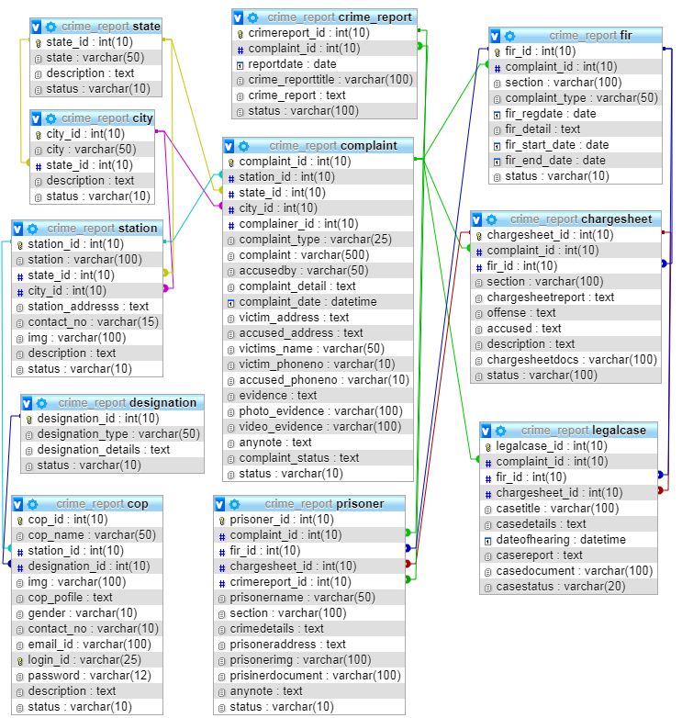

**DETAILED DESIGN**

1. **DETAIL DESIGN**
   1. **INTRODUCTION :**

The purpose of preparing this document is to explain complete design details of our Online crime management system**.**

This detailed design report will mainly contain the general definition and features of the project, design constraints, the overall system architecture and data architecture. Additionally, a brief explanation about our current progress and schedule of the project will be provided in related sections. Design of the system and subsystems/modules will be explained both verbally and visually by means of diagrams in order to help the programmer to understand all information stated in this document correctly and easily.

* 1. **APPLICABLE DOCUMENTS :**

The documents used during detailed design are

* System Requirements Document
* System Design
* Database Design
  1. **STRUCTURE OF THE SOFTWARE PACKAGE :**

The Components are –

* **Complainer module:**

This module stores complainer profile details. Complainer needs to register to the system. After the login complainer can file or lodge complaint in the complaint section. Complainer can view complaint status, fir status, crime details, charge sheet details, etc.

* **Complaint Module:**

Any public users can file complaint through online by entering Complaint reason, evidence, complaint details, complaint type, etc. Even police department can file complaint from their account if anyone gives complaint directly by visiting police station. Complaint can be closed anytime if both parties agrees for close.

* **Cop Account Module:**

This module allows station admin to add all cop details like name, address, designation, etc into the system. This can also edit or modify. Admin is the main user of the system. Cops has limited authority. Cops can login to the system by entering User Name and password. Different types of users like Inspector, Sup inspector, Constable, etc can be maintained in the system. Cops can update their profile details and they can change password.

* **Location Module:**

This module helps admin to store state, city records. Even admin can add police station records for each station.

* **FIR Module:**

If complaint is cognizable then goes to FIR. So in this module further investigation report is added into the system for cognizable complaints.

* **Charge sheet Module:**

In this module station user adds Charge sheet details will be added based on complaint.

* **Legal Case Module:**

Once the investigation like FIR, Charge sheet completes, all the details are submitted in to court. So the court hearing details will be added into the system

* **Criminal Module:**

Once the court finalize the judgment it will be sent to the criminal Records list.

* **Mail settings module:**

This module send mail notifications to complaint registrar about complaint registration details, FIR report, Charge sheet report, Legal case report, and criminal report.

* 1. **MODULAR DECOMPOSITION OF COMPONENTS :**
     1. **COMPLAINER MODULE COMPONENT:**
        1. **IDENTIFICATION OF MODULES :**

The modules identified in this component are:

* + - * + Complainer Registration
        + Complainer Login
        + Complainer Password
        + Complainer Change Password
      1. **STRUCTURE CHART FOR COMPLAINER:**



* + 1. **COMPLAINT MODULE COMPONENT:**
       1. **IDENTIFICATION OF MODULES :**

The modules identified in this component are:

* + - * Complaint reason
      * Complaint details
      * Complaint type
      * Evidence
      1. **STRUCTURE CHART FOR COMPLAINT:**



* + 1. **COP ACCOUNT COMPONENT:**
       1. **IDENTIFICATION OF MODULES :**

The modules identified in this component are:

* Cop Login
* Cop Profile
* Cop change Password
  + - 1. **STRUCTURE CHART FOR COP:**



* + 1. **LOCATION MODULE COMPONENT:**
       1. **IDENTIFICATION OF MODULES :**

The modules identified in this component are:

* Add State
* View State
* Add City
* View City
  + - 1. **STRUCTURE CHART FOR COP:**



* + 1. **CHARGE SHEET MODULE COMPONENT:**
       1. **IDENTIFICATION OF MODULES :**

The modules identified in this component are:

* Add Charge Sheet Report
* View Add Charge Sheet Report
  + - 1. **STRUCTURE CHART FOR CHARGE SHEET:**



1. **CODING**
   1. **INTRUDUCTION:**

The main goal of the coding or programming phase is to translate the design of the system produced during the design phase into code in a given programming language. It is then executed on a computer to verify whether the design is correct or not. In coding phase the output document is code can be extremely useful in enhancing the understandability. Internal documentation of code is done using comments in the program. Comments are textual statements that are meant for the program reader and are not executed.

The coding phase effects both testing and maintenance phases. Well write code can reduce the testing and maintenance effort. The goal of coding should be to reduce the testing and maintenance effort.

* 1. **MODULE CODING:**
     1. **dbconnection.php**

<?php

// Create connection

$con=mysqli_connect("localhost","root","","crime_report");

// Check connection,

if (mysqli_connect_errno($con))

{

echo "Failed to connect to MySQL: " . mysqli_connect_error();

}

?>

* + 1. **complainerlogin.php**

<?php

session_start();

include("dbconnection.php");

if(isset($_SESSION['complainer_id']))

{

echo "<script>window.location='compaccount.php';</script>";

}

if(isset($_POST[submit]))

{

$sql ="SELECT * FROM complainer WHERE email_id='$_POST[username]' and password='$_POST[password]' and status='Active'";

$qsql = mysqli_query($con,$sql);

echo mysqli_error($con);

if(mysqli_num_rows($qsql) >= 1)

{

$rspro = mysqli_fetch_array($qsql);

$_SESSION['complainer_id'] = $rspro[complainer_id];

echo "<script>window.location='compaccount.php';</script>";

}

else

{

echo "<script>alert('You have entered invalid login credentials..');</script>";

}

}

?>

<html>

<head>

<title> Transparent Login Form Design </title>

<link rel="stylesheet" type="text/css" href="style.css">

</head>

<body>

<div class="login-box">

<img src="avatar.png" class="avatar">

<h1>Login Here</h1>

<form method="post" action="">

<p>Email ID</p>

<input type="text" name="username" placeholder="Enter Username">

<p>Password</p>

<input type="password" name="password" placeholder="Enter Password">

<input type="submit" name="submit" value="Login">

<a href="recoverpassword.php">Forget Password</a>

</form>

</div>

</body>

</html>

* + 1. **cop.php**

<?php

include("header.php");

if(isset($_POST["submit"]))

{

$filename = rand() . $_FILES["img"]["name"];

move_uploaded_file($_FILES["img"]["tmp_name"],"imgcop/".$filename);

//Update Statement starts here

if(isset($_GET[editid]))

{

$sql ="UPDATE cop SET cop_name='$_POST[cop_name]',station_id='$_POST[station_id]',designation_id='$_POST[designation_id]'";

if($_FILES["img"]["name"] != "")

{

$sql = $sql . ",img='$filename'";

}

$sql = $sql . ",cop_pofile='$_POST[cop_pofile]',gender='$_POST[gender]',contact_no='$_POST[contact_no]',email_id='$_POST[email_id]',login_id='$_POST[login_id]',password='$_POST[password]',status='$_POST[status]' WHERE cop_id='$_GET[editid]'";

$qsql = mysqli_query($con,$sql);

if(mysqli_affected_rows($con) == 1)

{

echo "<script>alert('Cop Profile updated successfully');</script>";

}

else

{

echo mysqli_error($con);

}

}

//Update Statement ends here

//Insert statemetn starts here

else

{

$sql ="INSERT INTO cop (cop_name,station_id,designation_id,img,cop_pofile,gender,contact_no,email_id,login_id,password,status)values('$_POST[cop_name]','$_POST[station_id]','$_POST[designation_id]','$filename','$_POST[cop_pofile]','$_POST[gender]','$_POST[contact_no]','$_POST[email_id]','$_POST[login_id]','$_POST[password]','$_POST[status]')";

$qsql = mysqli_query($con,$sql);

if(mysqli_affected_rows($con) == 1)

{

echo "<script>alert('cop record inserted successfully');</script>";

echo "<script>window.location='cop.php';</script>";

}

else

{

echo mysqli_error($con);

}

}

}

?>

<?php

if(isset($_GET[editid]))

{

$sqledit = "SELECT * FROM cop WHERE cop_id='$_GET[editid]'";

$qsqledit = mysqli_query($con,$sqledit);

$rsedit = mysqli_fetch_array($qsqledit);

}

?>

<!-- Start Breadcrumb Section -->

<section class="breadcrumb-section parallax" style="background-image: url(assets/images/bg/breadcrumb4.jpg);">

<div class="container">

<div class="row">

<div class="col-md-12">

<div class="page-title">

<h1>CRIME REPORTING </h1>

</div>

</div>

</div>

</div>

</section>

<!-- End Breadcrumb Section -->

<form method="post" action="" enctype="multipart/form-data">

<!-- Start About Section -->

<section class="pad-t100 pad-b70">

<div class="container">

<div class="row">

<div class="col-md-12">

<div class="feature-4">

<center style="padding: 15px;"><h2><a href="#">COP</a></h2></center>

<hr>

<div class="intro-text">

<p>

<div class="row">

<div class="col-md-2">Cop Name</div>

<div class="col-md-10">

<input type="text" name="cop_name" id="cop_name" class="form-control" value="<?php echo $rsedit[cop_name]; ?>">

</div>

</div><br>

<div class="row">

<div class="col-md-2">Station</div>

<div class="col-md-10">

<select name="station_id" id="station_id" class="form-control">

<option value="">Select Station</option>

<?php

$sqlstation = "SELECT * FROM station WHERE status='Active'";

$qsqlstation = mysqli_query($con,$sqlstation);

while($rsstation = mysqli_fetch_array($qsqlstation))

{

if($rsstation[station_id] == $rsedit[station_id])

{

echo "<option value='$rsstation[station_id]' selected>$rsstation[station]</option>";

}

else

{

echo "<option value='$rsstation[station_id]'>$rsstation[station]</option>";

}

}

?>

</select>

</div>

</div><br>

<div class="row">

<div class="col-md-2">Designation</div>

<div class="col-md-10">

<select name="designation_id" id="designation_id" class="form-control">

<option value="">Select Designation</option>

<?php

$sqldesignation = "SELECT * FROM designation WHERE status='Active'";

$qsqldesignation = mysqli_query($con,$sqldesignation);

while($rsdesignation = mysqli_fetch_array($qsqldesignation))

{

if($rsdesignation[designation_id] == $rsedit[designation_id])

{

echo "<option value='$rsdesignation[designation_id]' selected>$rsdesignation[designation_type]</option>";

}

else

{

echo "<option value='$rsdesignation[designation_id]'>$rsdesignation[designation_type]</option>";

}

}

?>

</select>

</div>

</div><br>

<div class="row">

<div class="col-md-2">Image</div>

<div class="col-md-10">

<input type="file" name="img" id="img" class="form-control">

<?php

if(isset($_GET[editid]))

{

echo "<img src='imgcop/$rsedit[img]' style='width: 150px; height: 175px;'>";

}

?>

</div>

</div><br>

<div class="row">

<div class="col-md-2">Cop Profile</div>

<div class="col-md-10">

<textarea name="cop_pofile" id="cop_pofile" class="form-control"><?php echo $rsedit[cop_pofile]; ?></textarea>

</div>

</div><br>

<div class="row">

<div class="col-md-2">Gender</div>

<div class="col-md-10">

<select name="gender" id="gender" class="form-control">

<option value="">Select Gender</option>

<?php

$arr = array("Male","Female");

foreach($arr as $val)

{

if($val == $rsedit[gender])

{

echo "<option value='$val' selected>$val</option>";

}

else

{

echo "<option value='$val'>$val</option>";

}

}

?>

</select>

</div>

</div><br>

<div class="row">

<div class="col-md-2">Contact No</div>

<div class="col-md-10">

<input type="text" name="contact_no" id="contact_no" class="form-control" value="<?php echo $rsedit[contact_no]; ?>">

</div>

</div><br>

<div class="row">

<div class="col-md-2">Email Id</div>

<div class="col-md-10">

<input type="text" name="email_id" id="email_id" class="form-control" value="<?php echo $rsedit[email_id]; ?>">

</div>

</div><br>

<div class="row">

<div class="col-md-2">Login Id</div>

<div class="col-md-10">

<input type="text" name="login_id" id="login_id" class="form-control" value="<?php echo $rsedit[login_id]; ?>">

</div>

</div><br>

<div class="row">

<div class="col-md-2">Password</div>

<div class="col-md-10">

<input type="password" name="password" id="password" class="form-control" value="<?php echo $rsedit[password]; ?>">

</div>

</div><br>

<div class="row">

<div class="col-md-2">Confirm Password</div>

<div class="col-md-10">

<input type="password" name="cpassword" id="cpassword" class="form-control" value="<?php echo $rsedit[password]; ?>">

</div>

</div><br>

<div class="row">

<div class="col-md-2">Status</div>

<div class="col-md-10">

<select name="status" id="status" class="form-control">

<option value="">Select Status</option>

<?php

$arr = array("Active","Inactive");

foreach($arr as $val)

{

if($val == $rsedit[status])

{

echo "<option value='$val' selected>$val</option>";

}

else

{

echo "<option value='$val'>$val</option>";

}

}

?>

</select>

</div>

</div><br>

<hr><br>

<div class="row">

<div class="col-md-12">

<center><input type="submit" name="submit" id="submit" class="form-control btn btn-danger" style="width: 250px;" ></center>

</div>

</div><br>

</p>

</div>

</div>

</div>

</div>

</div>

</section>

</form>

<!-- End About Section -->

<?php

include("footer.php");

?>

* + 1. **viewstation.php**

<?php

include("header.php");

if(!isset($_SESSION['cop_id']))

{

echo "<script>window.location='index.php';</script>";

}

if(isset($_GET[delid]))

{

$sql = "DELETE FROM station WHERE station_id='$_GET[delid]'";

$qsql = mysqli_query($con,$sql);

if(mysqli_affected_rows($con) == 1)

{

echo "<script>alert('station record deleted successfully...');</script>";

echo "<script>window.location='viewstation.php';</script>";

}

else

{

echo mysqli_error($con);

}

}

?>

<!-- Start Text & image Section -->

<section class="pad50" style="background-color: rgba(250, 250, 250, 1);">

<div class="container">

<div class="row">

<div class="col-md-12">

<div class="text-section">

<h3 class="underline"><span>View Station</span></h3>

<p class="mb30">

<table id="datatable" class="table table-striped table-bordered">

<thead>

<tr>

<th><h5>Station</h5></th>

<th><h5>State</h5></th>

<th><h5>City</h5></th>

<th><h5>Address</h5></th>

<th><h5>Contact No.</h5></th>

<th><h5>Image</h5></th>

<th><h5>Description</h5></th>

<th><h5>Status</h5></th>

<th><h5>Action</h5></th>

</tr>

</thead>

<tbody>

<?php

$sql = "SELECT * FROM station";

$qsql = mysqli_query($con,$sql);

while($rs = mysqli_fetch_array($qsql))

{

echo "<tr>

<td>$rs[station]</td>

<td>$rs[state_id]</td>

<td>$rs[city_id]</td>

<td>$rs[station_addresss]</td>

<td>$rs[contact_no]</td>

<td>$rs[img]</td>

<td>$rs[description]</td>

<td>$rs[status]</td>

<td>

<a href='station.php?editid=$rs[0]' class='btn btn-warning'>Edit</a>

<a href='viewstation.php?delid=$rs[0]'onclick='return confirmdel()' class='btn btn-danger'>Delete</a>

</td>

</tr>";

}

?>

</tbody>

</table>

</p>

</div>

</div>

</div>

</div>

</section>

<!-- End Text & image Section -->

<?php

include("footer.php");

?>

<script>

function confirmdel()

{

if(confirm("Are you sure want to delete this record?") == true)

{

return true;

}

else

{

return false;

}

}

</script>

* + 1. **complaintregistration.php**

<?php

include("header.php");

if(isset($_POST["submit"]))

{

$photo_evidence = rand(). $_FILES["photo_evidence"]["name"];

move_uploaded_file($_FILES[photo_evidence][tmp_name],"imgphoto_evidence/".$photo_evidence);

$video_evidence = rand() . $_FILES["video_evidence"]["name"];

move_uploaded_file($_FILES[video_evidence][tmp_name],"imgvideo_evidence/".$video_evidence);

$sql ="INSERT INTO complaint (station_id, state_id, city_id,complainer_id, complaint_type, complaint, accusedby, complaint_detail, complaint_date, victim_address, accused_address, victim_phoneno, accused_phoneno, evidence, photo_evidence, video_evidence, anynote,complaint_status, status,victims_name)values('$_POST[station_id]', '$_POST[state_id]', '$_POST[city_id]','$_SESSION[complainer_id]', '$_POST[complaint_type]', '$_POST[complaint]', '$_POST[accusedby]', '$_POST[complaint_detail]', '$dttim', '$_POST[victim_address]', '$_POST[accused_address]', '$_POST[victim_phoneno]', '$_POST[accused_phoneno]', '$_POST[evidence]', '$photo_evidence', '$video_evidence', '$_POST[anynote]', '$_POST[complaint_status]', 'Pending','$_POST[victims_name]')";

$qsql = mysqli_query($con,$sql);

if(mysqli_affected_rows($con) == 1)

{

$insid = mysqli_insert_id($con);

echo "<script>alert('Compalint Registration done successfully');</script>";

echo "<script>window.location='complaintacknowledgementreport.php?insid=$insid';</script>";

}

else

{

echo mysqli_error($con);

}

}

?>

<!-- Start Breadcrumb Section -->

<section class="breadcrumb-section parallax" style="background-image: url(assets/images/police/complaintregistration.jpg);">

<div class="container">

<div class="row">

<div class="col-md-12">

<div class="page-title">

<h1>Complaint Registration Panel </h1>

</div>

</div>

</div>

</div>

</section>

<!-- End Breadcrumb Section -->

<br>

<form method="post" action="" enctype="multipart/form-data">

<div class="container">

<div class="row">

<div class="col-md-12">

<div class="panel panel-primary">

<div class="panel-heading">

<h3 class="panel-title">REGISTER YOUR COMPLAINT HERE</h3>

<span class="pull-right">

<!-- Tabs -->

<ul class="nav panel-tabs">

<li class="active"><a href="#tab1" data-toggle="tab">Police Station</a></li>

<li><a href="#tab2" data-toggle="tab">Your detail</a></li>

<li><a href="#tab3" data-toggle="tab">Complaint detail</a></li>

<li><a href="#tab4" data-toggle="tab">Victim Detail</a></li>

<li><a href="#tab5" data-toggle="tab">Evidence detail</a></li>

</ul>

</span>

</div>

<div class="panel-body">

<div class="tab-content" style="height: 350px;">

<div class="tab-pane active" id="tab1">

<div class="row" style="padding-top: 13px;">

<div class="col-md-2">State </div>

<div class="col-md-10">

<select name="state_id" id="state_id" class="form-control" onchange="loadcity(this.value)">

<option value="">Select State</option>

<?php

$sqlstate= "SELECT * FROM state WHERE status='Active'";

$qsqlstate= mysqli_query($con,$sqlstate);

while($rsstate = mysqli_fetch_array($qsqlstate))

{

if($rsstate[state_id] == $rsedit[state_id])

{

echo "<option value='$rsstate[state_id]' selected>$rsstate]</option>";

}

else

{

echo "<option value='$rsstate[state_id]'>$rsstate[state]</option>";

}

}

?>

</select>

</div>

</div><br>

<div class="row">

<div class="col-md-2">City </div>

<div class="col-md-10" id="divcity"><?php include("ajaxcity.php"); ?></div>

</div><br>

<div class="row">

<div class="col-md-2">Station </div>

<div class="col-md-10" id="divstation"><?php include("ajaxstation.php"); ?></div>

</div><br>

</div>

<div class="tab-pane" id="tab2">

<?php

if(isset($_SESSION[complainer_id]))

{

$sqlcomplainerdetail = "SELECT * FROM complainer where complainer_id='$_SESSION[complainer_id]'";

$qsqlcomplainerdetail = mysqli_query($con,$sqlcomplainerdetail);

$rscomplainerdetail = mysqli_fetch_array($qsqlcomplainerdetail);

}

?>

<div class="row" style="padding-top: 10px;">

<div class="col-md-2">Name</div>

<div class="col-md-10">

<input type="text" name="name" id="name" class="form-control" value="<?php echo $rscomplainerdetail[name]; ?>" readonly>

</div>

</div><br>

<div class="row" >

<div class="col-md-2">Email ID</div>

<div class="col-md-10">

<input type="text" name="email_id" id="email_id" class="form-control" value="<?php echo $rscomplainerdetail[email_id]; ?>" readonly>

</div>

</div><br>

<div class="row">

<div class="col-md-2">Phone Number</div>

<div class="col-md-10">

<input type="text" name="phoneno" id="phoneno" class="form-control" value="<?php echo $rscomplainerdetail[phoneno]; ?>" readonly>

</div>

</div><br>

</div>

<div class="tab-pane" id="tab3">

<?php

/*

<div class="row">

<div class="col-md-2">Complaint Type</div>

<div class="col-md-10">

<input type="text" name="complaint_type" id="complaint_type" class="form-control">

</div>

</div><br>

*/

?>

<div class="row" style="padding-top: 7px;">

<div class="col-md-2" style="padding-top: 10px;">Complaint Title</div>

<div class="col-md-10">

<input type="text" name="complaint" id="complaint" class="form-control">

</div>

</div><br>

<div class="row">

<div class="col-md-2">Complaint Detail</div>

<div class="col-md-10">

<textarea name="complaint_detail" id="complaint_detail" class="form-control"></textarea>

</div>

</div><br>

<div class="row">

<div class="col-md-2">Accused By</div>

<div class="col-md-10">

<input type="text" name="accusedby" id="accusedby" class="form-control" placeholder="Enter name">

</div>

</div><br>

<div class="row">

<div class="col-md-2">Accused Address</div>

<div class="col-md-10">

<textarea name="accused_address" id="accused_address" class="form-control"></textarea>

</div>

</div><br>

<div class="row">

<div class="col-md-2">Accused Phone No.</div>

<div class="col-md-10">

<input type="text" name="accused_phoneno" id="accused_phoneno" class="form-control">

</div>

</div><br>

</div>

<div class="tab-pane" id="tab4">

<div class="row" style="padding-top: 10px;">

<div class="col-md-2" style="padding-top: 10px;">Victim's name</div>

<div class="col-md-10">

<input type="text" name="victims_name" id="victims_name" class="form-control">

</div>

</div><br>

<div class="row">

<div class="col-md-2" style="padding-top: 10px;">Victim Address</div>

<div class="col-md-10">

<textarea name="victim_address" id="victim_address" class="form-control"></textarea>

</div>

</div><br>

<div class="row">

<div class="col-md-2">Victim Phone No.</div>

<div class="col-md-10">

<input type="text" name="victim_phoneno" id="victim_phoneno" class="form-control">

</div>

</div><br>

</div>

<div class="tab-pane" id="tab5">

<div class="row" style="padding-top: 10px;">

<div class="col-md-2">Any Evidence</div>

<div class="col-md-10">

<textarea name="evidence" id="evidence" class="form-control"></textarea>

</div>

</div><br>

<div class="row">

<div class="col-md-2">Any Photo Evidence</div>

<div class="col-md-10">

<input type="file" accept="image/*" name="photo_evidence" id="photo_evidence" class="form-control">

</div>

</div><br>

<div class="row">

<div class="col-md-2">Any Video Evidence</div>

<div class="col-md-10">

<input type="file" accept="video/mp4,video/x-m4v,video/*" name="video_evidence" id="video_evidence" class="form-control">

</div>

</div><br>

<?php

if(isset($_SESSION['cop_id']))

{

?>

<div class="row">

<div class="col-md-2">AnyNote</div>

<div class="col-md-10">

<textarea name="anynote" id="anynote" class="form-control"></textarea>

</div>

</div><br>

<?php

}

?>

</div>

</div>

<hr><br>

<center><input type="submit" name="submit" class="form-control btn btn-primary" value="Register Complaint" style='height: 60px;width: 250px;'></center>

</div>

</div>

</div>

</div>

</div>

</form>

<?php

include("footer.php");

?>

<style>

/*Panel tabs*/

.panel-tabs {

position: relative;

bottom: 30px;

clear:both;

border-bottom: 1px solid transparent;

}

.panel-tabs > li {

float: left;

margin-bottom: -1px;

}

.panel-tabs > li > a {

margin-right: 2px;

margin-top: 4px;

line-height: .85;

border: 1px solid transparent;

border-radius: 4px 4px 0 0;

color: #ffffff;

}

.panel-tabs > li > a:hover {

border-color: transparent;

color: #ffffff;

background-color: transparent;

}

.panel-tabs > li.active > a,

.panel-tabs > li.active > a:hover,

.panel-tabs > li.active > a:focus {

color: #fff;

cursor: default;

-webkit-border-radius: 2px;

-moz-border-radius: 2px;

border-radius: 2px;

background-color: rgba(255,255,255, .23);

border-bottom-color: transparent;

}

</style>

<script>

function loadcity(state_id)

{

if (state_id == "")

{

document.getElementById("divcity").innerHTML = "<select name='city_id' id='city_id' class='form-control'><option value=''>Select City</option>";

return;

}

else

{

if (window.XMLHttpRequest) {

// code for IE7+, Firefox, Chrome, Opera, Safari

xmlhttp = new XMLHttpRequest();

} else {

// code for IE6, IE5

xmlhttp = new ActiveXObject("Microsoft.XMLHTTP");

}

xmlhttp.onreadystatechange = function() {

if (this.readyState == 4 && this.status == 200) {

document.getElementById("divcity").innerHTML = this.responseText;

}

};

xmlhttp.open("GET","ajaxcity.php?state_id="+state_id,true);

xmlhttp.send();

}

}

</script>

<script>

function loadpolicestation(city_id)

{

if (city_id == "")

{

document.getElementById("divstation").innerHTML = "<select name='station_id' id='station_id' class='form-control'><option value=''>Select Station</option>";

return;

}

else

{

if (window.XMLHttpRequest) {

// code for IE7+, Firefox, Chrome, Opera, Safari

xmlhttp = new XMLHttpRequest();

} else {

// code for IE6, IE5

xmlhttp = new ActiveXObject("Microsoft.XMLHTTP");

}

xmlhttp.onreadystatechange = function() {

if (this.readyState == 4 && this.status == 200) {

document.getElementById("divstation").innerHTML = this.responseText;

}

};

xmlhttp.open("GET","ajaxstation.php?city_id="+city_id,true);

xmlhttp.send();

}

}

</script>

1. **TESTING**
   1. **INTRODUCTION**

Testing is the process of detecting errors. Testing performs a very special role for quality assurance and for ensuring the reliability of software. The results of testing are used later on during maintenance also.

* 1. **PSYCHOLOGY OF TESTING**The aim of testing is often to demonstrate that a program works by showing that it has no errors. The basic of testing phase is to detect the errors that may be present in the program hence one should not start testing with the intent to show that a program doesn’t work. Testing is the process of executing a program with the intent of finding errors.
  2. **TESTING OBJECTIVES**

The main objective of testing is to cover a host of errors, systematically and with minimum effort and time. Starting formally, we can say, testing is a process of executing a program with the intent of finding an error.

A successful test is one that uncovers an as yet undiscovered error

* A good test case is one that has a high probability of finding an error, if it exists.
* The tests an inadequate to detect possibly present errors
* The software more or less confirms to the quality and reliable standards.
  1. **SOFTWARE TESTING**

Software testing is a critical element of software quality assurance and represents. The ultimate review if a specification design, coding. The testing phase involves the testing of system using various test data; the system under study is tested. Those test data, errors were found and connected by following testing steps and corrections are recorded for future references. Thus, a series testing is performed on the system before it is ready for implementation.

* 1. **LEVELS OF TESTING**
* Unit testing
* Integration testing
* Validation testing
* Output testing
* User acceptance testing
  1. **UNIT TESTING**

Unit testing focuses verification effort on the smallest unit of software unit of software i.e. the module. using detailed design and the process specification testing is done to uncover errors within the boundary of the module all the modules must be successful in the unit test before the start of integration testing begins.

In this project unit testing is very much essential because the error is accurate. Unit testing is testing of the different units or modules of a system in isolation. Testing is done to check whether each module in the software works properly so that it gives desired output in each module in the software works properly

* 1. **INTEGRATION TESTING**

In integration testing all the code modules are put together and tested for desired outputs. The modules units tested are integration and tested. All the modules are combined in this resting step. Then the entire program is tested as whole. The integration testing is done.

* 1. **OUTPUT TESTING**

Feeding sample valid input image and then comparing the ratio obtained in the compressed output image with expected ratio conduct it. Correctness of the output depends on the inputted image.

* 1. **SYSTEM TESTING**

In system testing entire system is tested as whole with all forms, code modules and class modules. After the integration testing the whole of the system is tested in different environments and it is found that the system well without giving any runtime error. Hence after the testing it is concluded that the system will work fine in all environments.

* 1. **TEST CASES**
     1. **Test unit : Hosteller Registration**

|  |  |  |  |  |
| --- | --- | --- | --- | --- |
| **Serial No.** | **Condition**  **To be Tested** | **Test Data** | **Expected Output** | **Remarks** |
| 1. | If hosteller type is not selected | Hosteller type | Kindly select hosteller type | SUCCESSFULL |
| 2 | If hosteller name contains other than character types | Name | Name should contain only alphabets | SUCCESSFUL |
| 3 | If email id does not contains proper format | Email id | Entered email id is not valid | SUCCESSFUL |
| 4 | If password length is less than 6 | password | Password must contain at least 6 characters. | SUCCESSFUL |
| 5 | If password and confirm password does not match. | password,  confirm password | Password and Confirmed password are not matching. | SUCCESSFUL |
| 6 | If date of birth is not selected | Date of birth | Date of birth should not be empty | SUCCESSFUL |
| 7 | If father name contains other than character types | Father name | Father Name should contain only alphabets | SUCCESSFUL |
| 8 | If mother name contains other than character types | Mother name | mother Name should contain only alphabets | SUCCESSFUL |
| 9 | If address contains other than character types | address | address should contain only alphabets | SUCCESSFUL |
| 10 | If contact number does not contain 10 digits | Contact number | Contact number should contain 10 digits | SUCCESSFUL |

**Input and Output Screen**

1. **INPUT AND OUTPUT SCREEN**
   1. **Home Page**

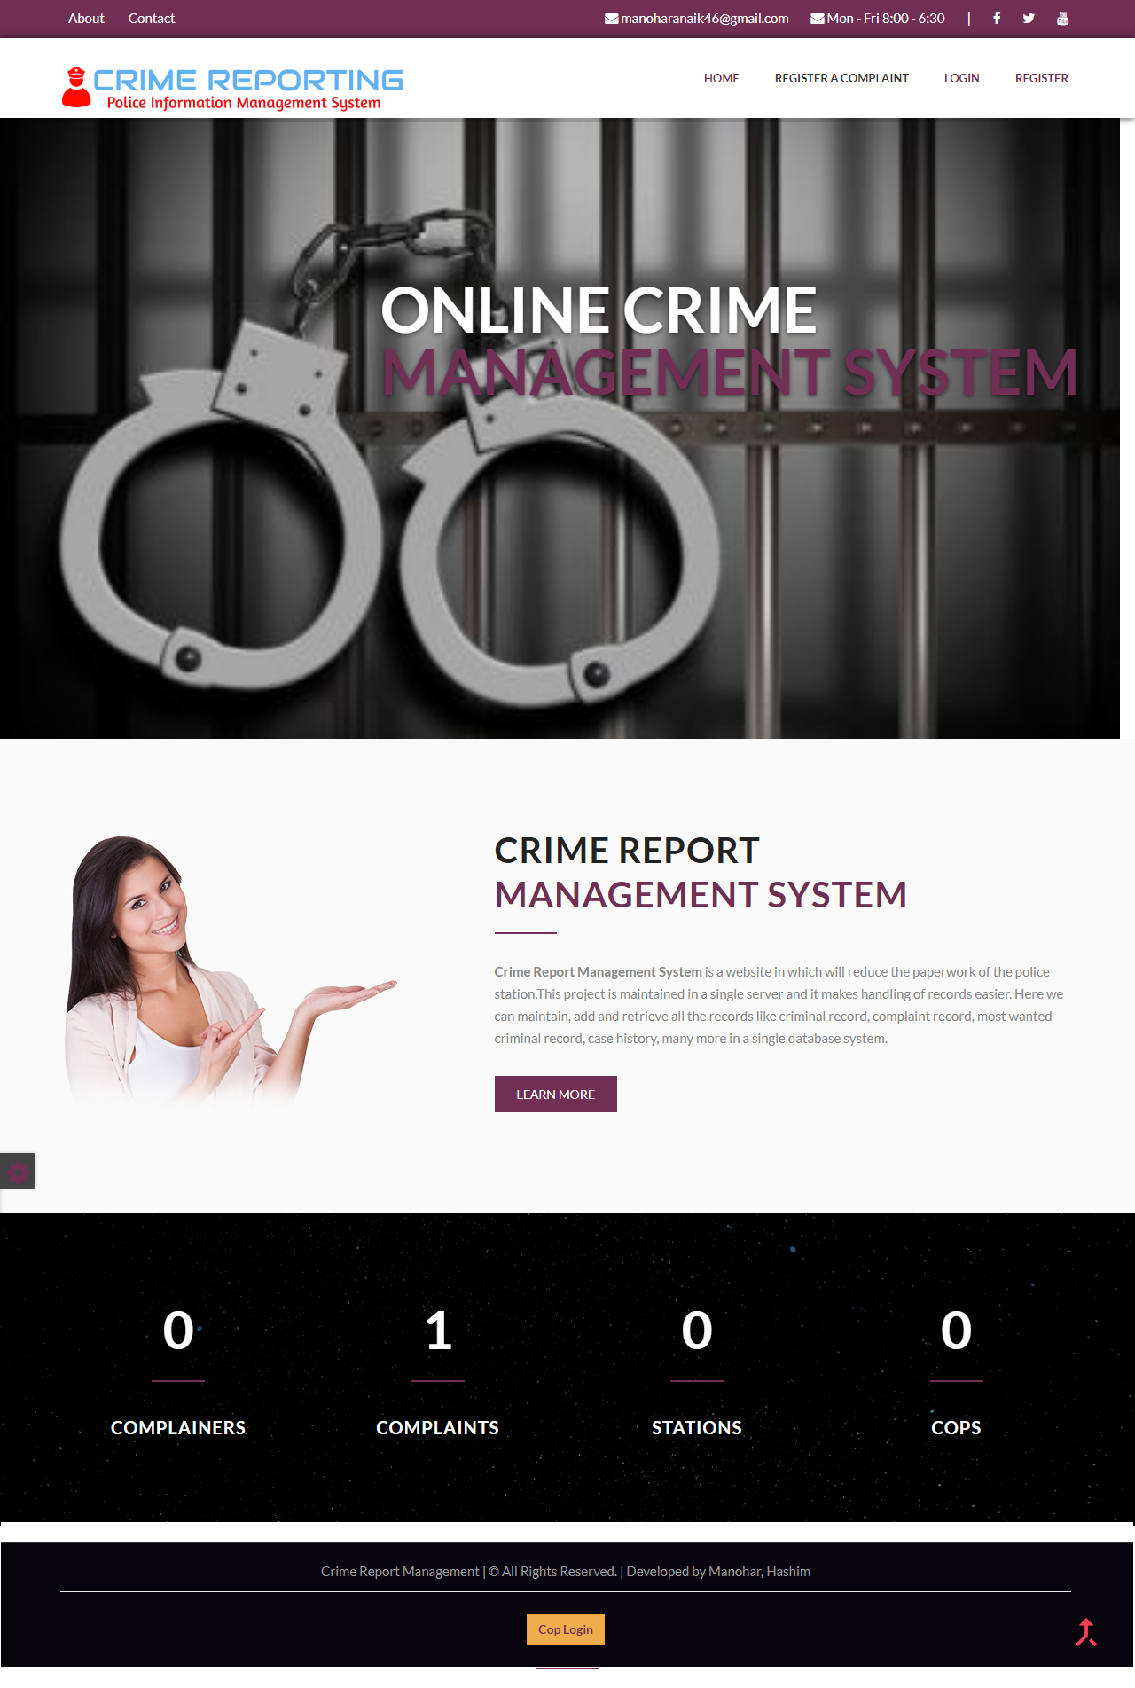

* 1. **Complainer Registration**

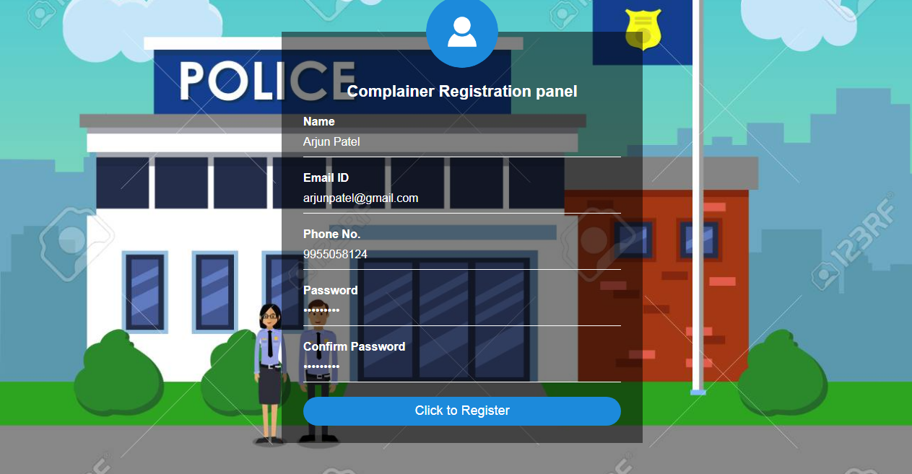

* 1. **Complainer Login**

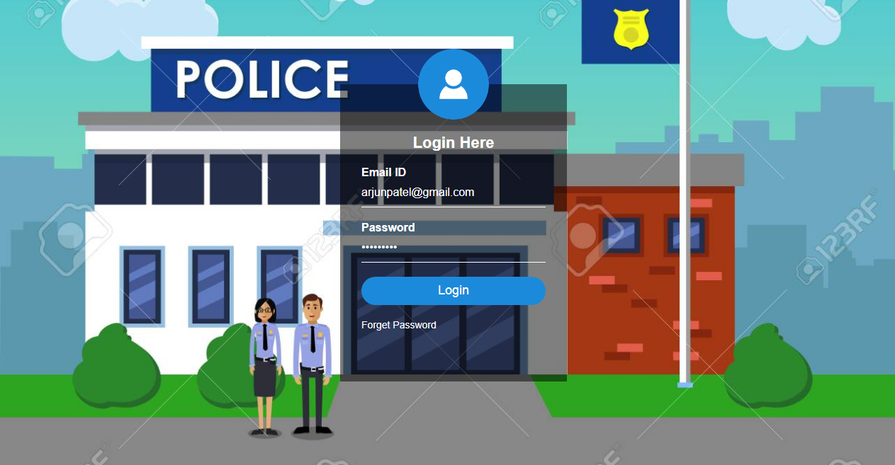

* 1. **Complaint Registration**

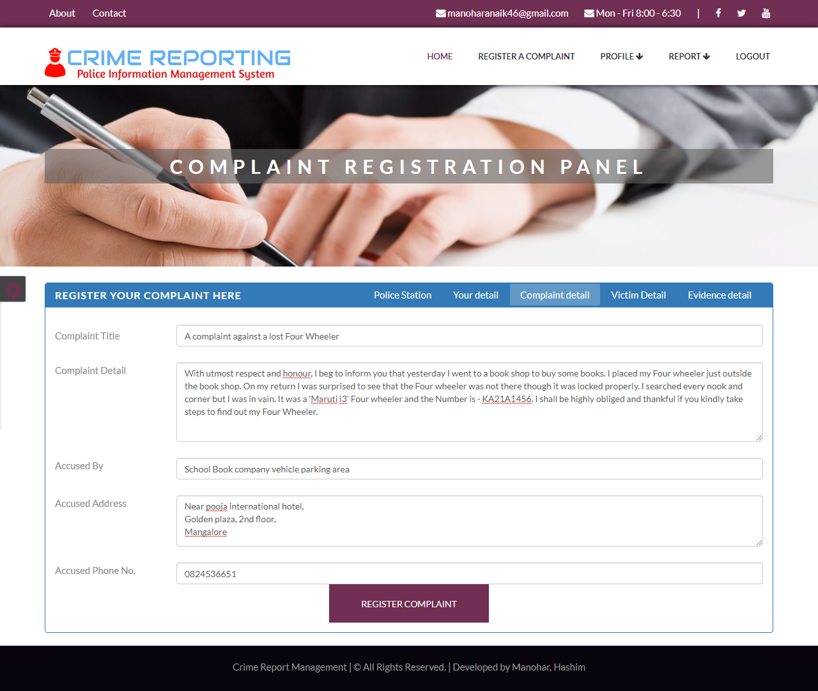

* 1. **Admin Dashboard**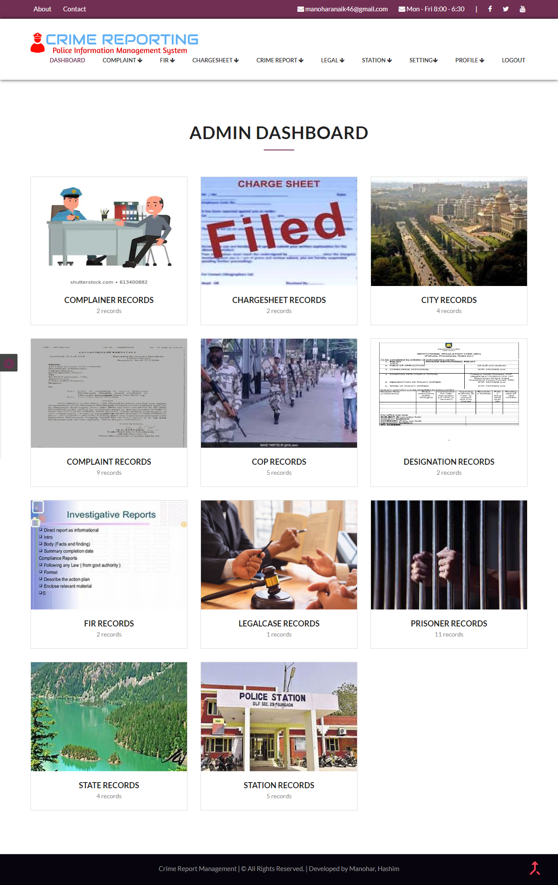
  2. **FIR REGISTRATION**

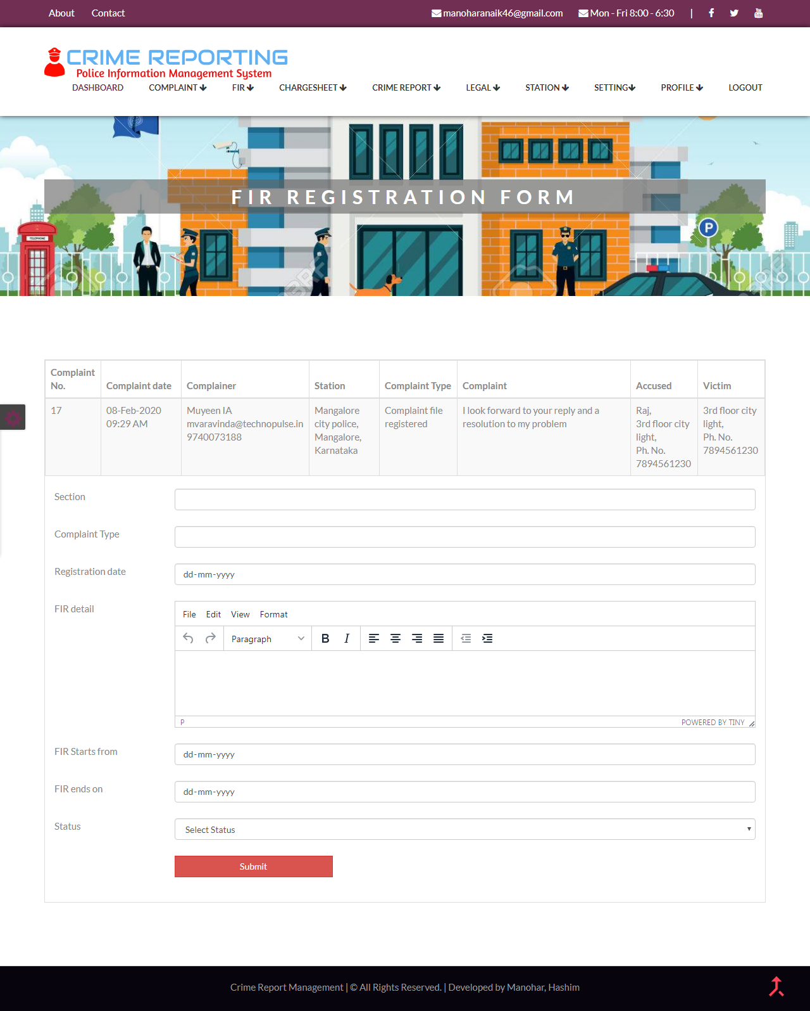

* 1. **VIEW CHARGESHEET**

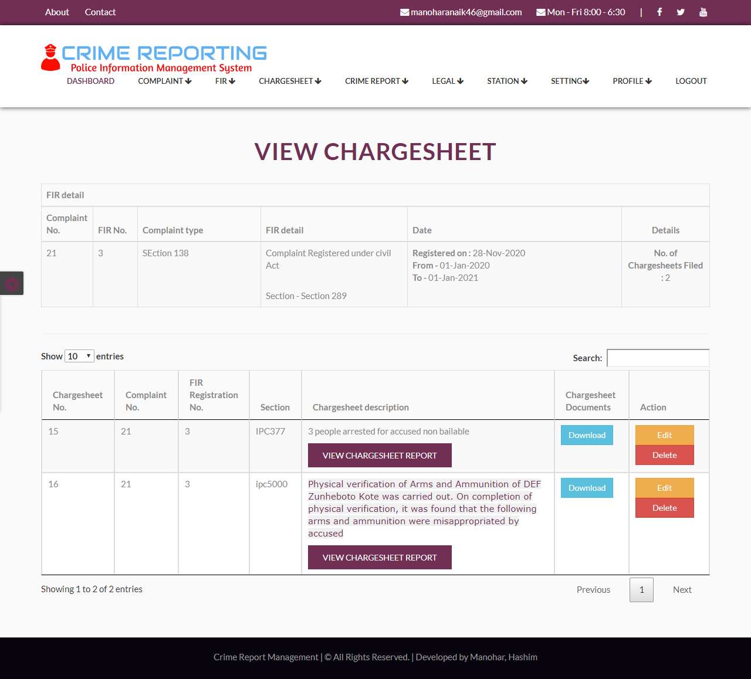

* 1. **CRIME REPORT**

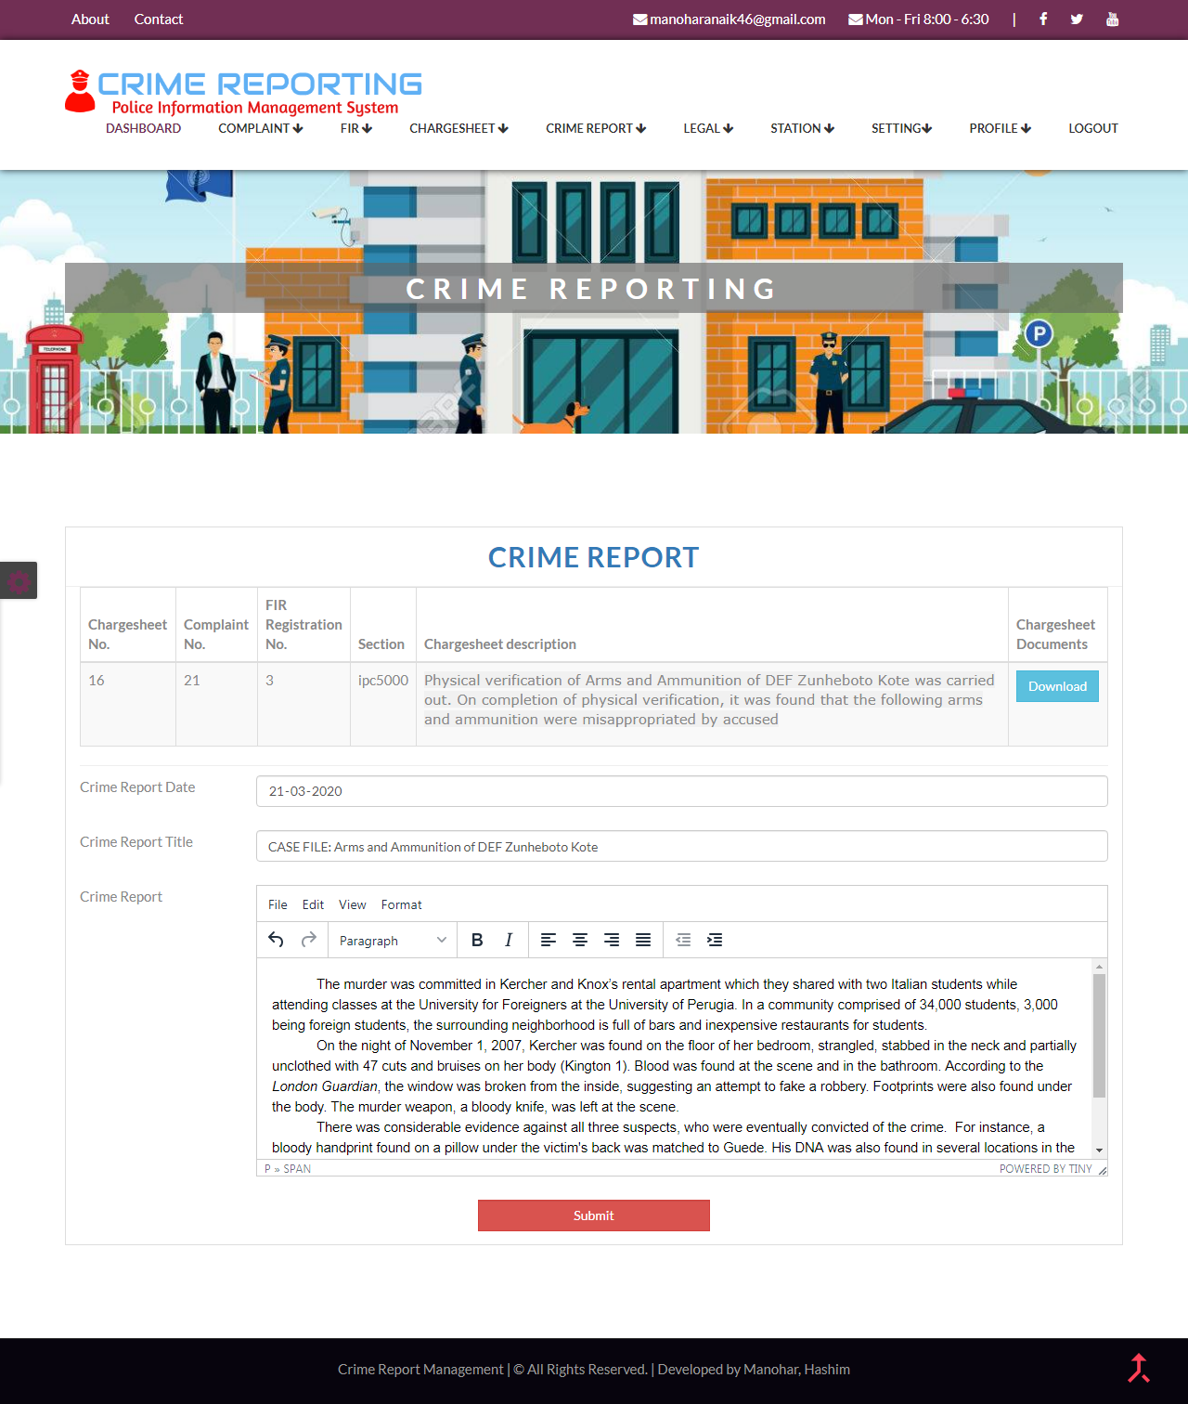

* 1. **ADD COP**

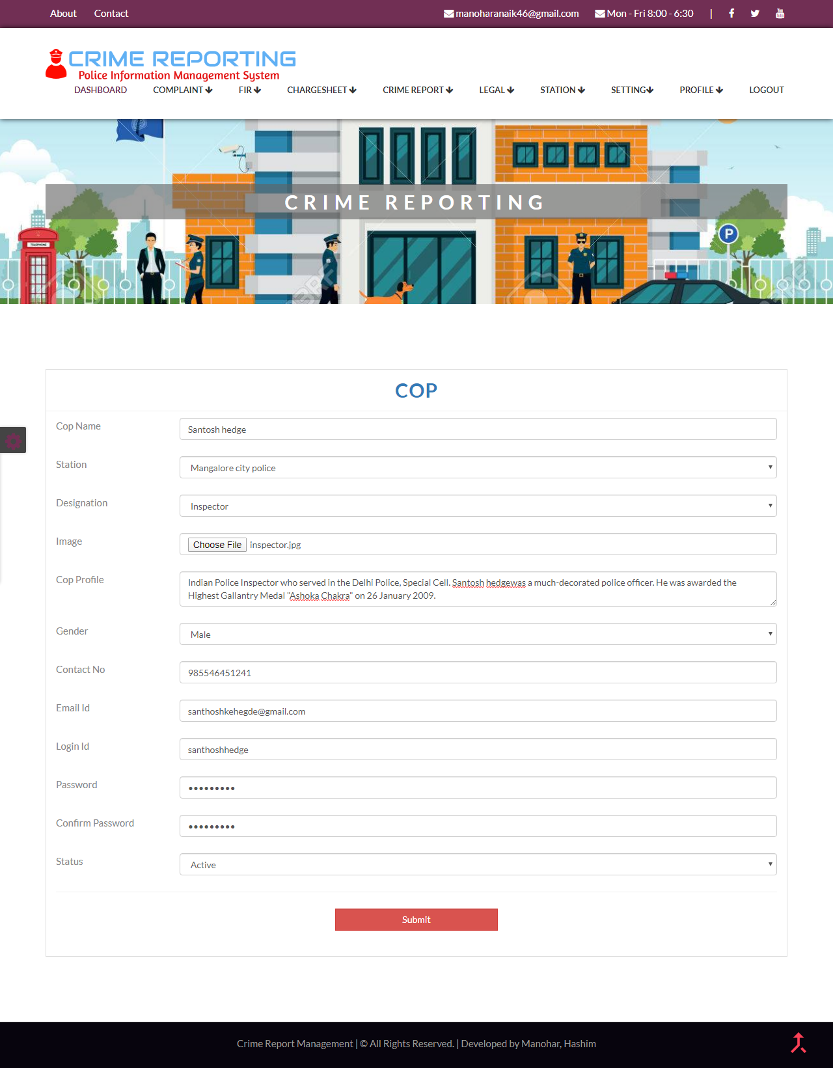

* 1. **VIEW COP**

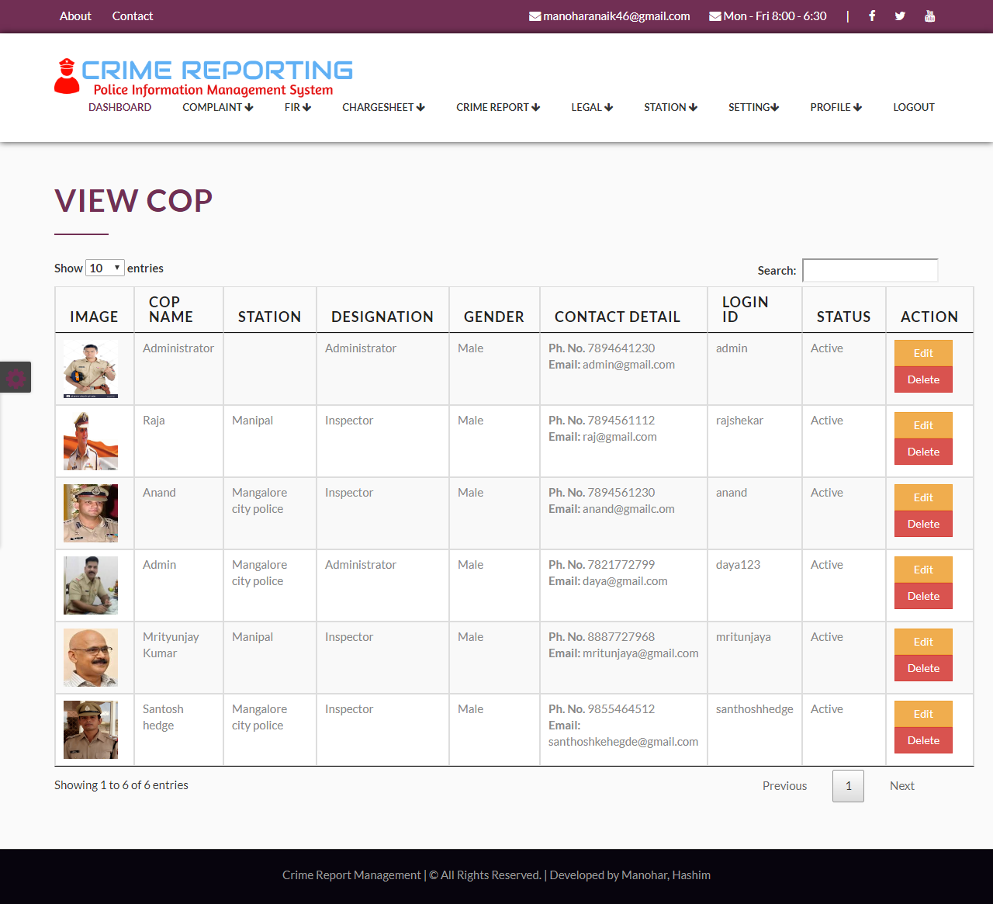

* 1. **ADD STATION**

